***This is a practical assignment. (submission is mandatory)***

**AGENDA: Enabling communication between overlapping networks which will solve Private IP exhaustion with Private NAT Solution.**

**Solution Overview:**

This solution illustrates a mechanism to conserve and manage the RFC1918 IP address space allocation using the concept of routable & non-routable IP ranges. Furthermore, the solution describes how to connect overlapping CIDR ranges using a Private NAT Gateway that is located in the non-overlapping (or routable) IP space.

If a business unit in an organization wishes to deploy a workload that demands the use of thousands of IP addresses, the workload will be deployed on the non-routable IP address range. The non-routable IP space is used by many other business units and the overlapping nature of this space makes it non-routable. The workload will be assigned a small routable IP address range by the centralized IP Address Management (IPAM) team. The assigned routable IP range can be used by the individual business units to connect to the consolidated network. When identifying routable and non-routable IP spaces, use compatible CIDR ranges, as the CIDR blocks that can be attached as the secondary CIDR to a VPC are restricted based on the VPC’s primary CIDR block.

The following diagram (Figure 1) shows how to use AWS Transit Gateway and Private NAT to solve IP exhaustion problem and enable communication between two Amazon Virtual Private Clouds (VPCs) with overlapping CIDR ranges.

### **Scenario Walkthrough:**

In this section, we will use routable and non-routable IP address ranges to establish connectivity from VPC-A to VPC-B with overlapping CIDRs using Private NAT Gateway. This walkthrough is divided into three sections as follows:

1. Identify the routable IP address space
2. Assign the IP address space
3. Configure the routing to enable connectivity

### **1. Identify the routable IP address space:**

For non-routable address ranges, any IPv4 address range, including RFC 1918 or publicly routable IP ranges can be used as the secondary CIDR block of the VPC. Multiple teams can use the same secondary address range and thus, it should be treated as non-routable. Please keep in mind that there are some constraints when it comes to allocating IP addresses in a VPC.

The routable space is carefully allocated by the IP management team from the central routable IP pool. Only the routable IP space is unique and advertised to the organization’s consolidated network through Transit Gateway or Virtual Private Gateway.

### **2. Assign the IP address space:**

In this blog post, the project team provisions the VPCs with primary CIDR from the routable range and uses the non-routable CIDR range as the secondary CIDR. In this walk through, non-routable and routable IP addresses are allocated as follows:

For non-routable address range we have assigned 100.64.0.0/16 IP range from the Shared Address Space(RFC 6598: i.e., 100.64.0.0/10) as the secondary CIDR to both VPC-A and VPC-B. For routable address range, we have assigned 10.0.1.0/24 to VPC-A and 10.0.2.0/24 to VPC-B as primary address ranges from RFC1918. These CIDR ranges were selected after ensuring that they are compatible with the limitations for adding a secondary CIDR block to VPC, as described in the “Solution Overview” section.

The IP address allocation for both VPC-A and VPC-B is depicted in the following diagram (Figure 2).

### **3. Configure the routing to enable connectivity:**

Now that we have assigned the primary and secondary IP ranges for both VPC-A and VPC-B, let’s configure the routing to enable the connectivity between VPC-A and VPC-B. We are using an internal Application Load Balancer (ALB) to expose the resources in the non-routable subnet inside VPC-B. A Private NAT Gateway is deployed in VPC-A to Source NAT the non-routable IP to a routable IP in VPC-A.

To achieve this desired state of connectivity:

1. ALB is placed in the routable subnets in VPC-B and the back-end instances in the non-routable subnets in VPC-B.
2. Private NAT Gateway is created in the routable subnets in VPC-A and the “SourceInstance- VPC-A” is created in the non-routable subnets in VPC-A to test the connectivity.
3. A Transit Gateway is created with two attachments, in routable subnets of both VPC-A and VPC-B.

Now that we understand the architecture, let’s walk through a life of a packet when “SourceInstance-VPC-A” in VPC-A communicates with the ALB in VPC-B.

### **Packet flow from SourceInstance-VPC-A to the WebServer:**

**Step 1:** “SourceInstance-VPC-A” in VPC-A wishes to communicate with the WebServer in VPC-B, which is located behind the ALB in VPC-B. As a result, the packet originates from “SourceInstance-VPC-A” (Source IP: 100.64.0.10/32) and is headed to the ALB. The “SourceInstance-VPC-A” will do a DNS lookup on the ALB DNS name to get the destination IP (Destination IP: 10.0.2.x/32). The “Non-Routable Subnet-RT“ in VPC-A is configured to route the traffic destined for 10.0.2.0/24 to the Private NAT Gateway.

**Step 2:** The Private NAT Gateway translates Source IP from non-routable IP address to a routable IP address and then sends the traffic to the Transit Gateway Attachment in VPC-A as it is associated with the “Routable Subnet-RT” route table in VPC-A.

**Step 3:** Transit Gateway uses the 10.0.2.0/24 route and sends the traffic to VPC-B Transit Gateway Attachment.

**Step 4:** TGW ENI in VPC-B uses the VPC-B local route to forward the traffic to the ALB which then forwards the traffic to the WebServer behind the ALB.

### **Steps to return traffic from WebServer to the SourceInstance-VPC-A:**

**Step 5:** WebServer behind the ALB receives the request sent by the “SourceInstance-VPC-A” instance and returns a response to the ALB using the VPC-B local route.

**Step 6:** The ALB forwards the response traffic to the Transit Gateway Attachment in VPC-B as it is associated with the “Routable Subnet-RT” route table in VPC-B. This response traffic from the ALB has source IP address of the ALB and destination IP address of the Private NAT Gateway.

**Step 7:** Transit Gateway uses the 10.0.1.0/24 route and sends the traffic to VPC-A Transit Gateway Attachment.

**Step 8:** The TGW ENI in VPC-A uses the local route to forward the traffic to the Private NAT Gateway, which then translates the destination IP to that of the “SourceInstance-VPC-A” instance. This packet is routed to “SourceInstance-VPC-A” using the local route

## Prerequisites:

To complete this walk-through, you need:

1. An [AWS account](https://portal.aws.amazon.com/billing/signup#/start)
2. An IAM user with access to AWS resources, including Systems Manager, AWS Transit Gateway, VPC and [Amazon EC2](https://aws.amazon.com/ec2/).

## Deployment Instructions:

In this section, we demonstrate how to deploy the architecture from figure 1, including Transit Gateway, VPCs, Subnets, Private NAT Gateway, Transit Gateway Route Tables, VPC Route Tables, Application Load Balancer, EC2 instances, etc., using the provided CloudFormation template.

1. Click on [](https://us-east-1.console.aws.amazon.com/cloudformation/home?region=us-east-1#/stacks/create/review?templateURL=https://awsiammedia.s3.amazonaws.com/public/sample/Solve-Private-IP-exhaustion-Private-NAT/tgw_natgw_overlapping_cidrs.yaml&stackName=PrivateNATGatewayDemo)to deploy the CloudFormation template.
2. By default, the link takes you to the Create stack page within the CloudFormation console in the N. Virginia Region (us-east-1) and the solution’s CloudFormation template is automatically populated. You can change the region at the top right corner of the console if needed.
3. If needed to deploy with the help of direct upload of code, below is the Cloud formation code which will deploy the setup.



1. Graphical user interface, text, application, email

   Description automatically generated
2. Graphical user interface, text, application, email

   Description automatically generated

1. Enter a name for the stack in the Stack name and all the required parameters are populated with default values. In our demo environment, we have chosen to name our stack “PrivateNATGatewayDemo”. Click “Create Stack” to continue.

**Below are the modules created by default with EC2server,VPC setup, Elastic Load Balancer created with the help of cloud formation template as per below snippets:**

1. Graphical user interface, application, Word

   Description automatically generated
2. 
3. Graphical user interface, application

   Description automatically generated
4. Graphical user interface, application

   Description automatically generated
5. 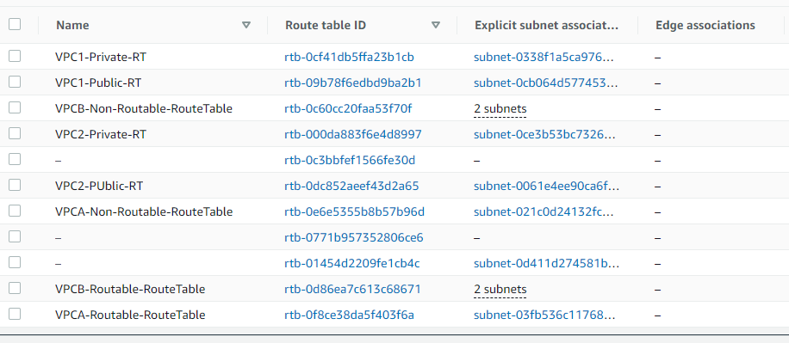
6. Graphical user interface, text, application

   Description automatically generated

## Validation:

1. To connect to the SourceInstance-VPC-A instance securely using Session Manager, select the instance ID in the EC2 console and click on the Connect button.
2. There are four different ways to connect to the EC2 instance. Select the Session Manager tab and Click on Connect which opens a new browser-based shell session of your instance. Please keep in mind that it may take few minutes to be able to connect to the SourceInstance-VPC-A instance via the Session Manager.

1. To verify that the “SourceInstance-VPC-A” can reach the web service which is running in VPC-B (100.64.0.0/24 non-routable subnet), use curl to connect the ALB DNS name(Refer ALB Hostname value in the outputs section of the CloudFormation stack).

## Verification:

1. Need to grab LB URL from Load Balancing Dashboard

**curl <ALB DNS>** (Here the ALB URL will be the DNS name from Load balancer Dashboard**)**



## Cleanup:

After testing the connectivity, please go ahead and [delete](https://docs.aws.amazon.com/AWSCloudFormation/latest/UserGuide/cfn-console-delete-stack.html) the CloudFormation stack to avoid any costs associated with the resources launched by the CloudFormation template.

## Conclusion:

In this post, you learned how to use routable and non-routable IP CIDR ranges along with AWS Transit Gateway and Private NAT Gateway to tackle Private IP exhaustion issue and enable communication between two Amazon VPCs with overlapping CIDR ranges. Please note that this illustration shows how to establish connectivity between two VPCs with over-lapping CIDR’s. The same can be extended to a VPC and on-premises network or two on-premises networks with overlapping CIDRs.